**Functional insights from top upregulated genes**

From a GEO2R differential expression analysis, the top 10% of exclusively upregulated genes were extracted and filtered. Among these, six key proteins were identified. These proteins span diverse functional classes, yet converge on enhancing cellular resilience under desiccation stress.

Each protein’s role and its associated pathway:

**1. Phosphoribosylaminoimidazolecarboxamide Formyltransferase / IMP Cyclohydrolase (ATIC)**

* Function: Bifunctional enzyme in *de novo purine biosynthesis*.
* Pathway: *Purine metabolism* (KEGG: ko00230)
* Role in Desiccation Tolerance:
  + 1. Supports nucleotide pool maintenance during stress-induced DNA repair and replication arrest.
    2. Ensures ATP/GTP availability for energy-intensive protective responses.

Reference**:** [EMBL-EBI Mechanism Atlas](https://www.ebi.ac.uk/thornton-srv/m-csa/entry/646/)

(<https://www.ebi.ac.uk/thornton-srv/m-csa/entry/646/>)

**2. Spherulin-1B Precursor**

* Function: Putative cell wall-associated protein originally identified in *resurrection plants*.
* Pathway: Likely involved in *cell wall remodeling and reinforcement*.
* Role in Desiccation Tolerance:
  1. Enhances mechanical stability of cells during dehydration.
  2. May act as a hydration buffer or scaffold for protective proteins.

Reference**:** [Frontiers in Plant Science](https://www.frontiersin.org/articles/10.3389/fpls.2013.00482/full)

(<https://www.frontiersin.org/journals/plant-science/articles/10.3389/fpls.2013.00482/full>)

**3. LTI30 / XERO2 Dehydrin**

* Function: Group II LEA (Late Embryogenesis Abundant) protein.
* Pathway: *ABA signaling*, *ROS detoxification*, *membrane stabilization*
* Role in Desiccation Tolerance:
  1. Protects membranes and proteins from aggregation.
  2. Enhances hydrogen peroxide scavenging and proline accumulation.

Reference: [Frontiers in Plant Science](https://www.frontiersin.org/articles/10.3389/fpls.2015.00893/full)

(<https://www.frontiersin.org/journals/plant-science/articles/10.3389/fpls.2015.00893/full>)

**4. Lactoylglutathione Lyase Family Protein (Glyoxalase I)**

* Function: Detoxifies *methylglyoxal*, a cytotoxic byproduct of glycolysis.
* Pathway: *Methylglyoxal detoxification* → *Glutathione metabolism*
* Role in Desiccation Tolerance:

1. Prevents carbonyl stress and protein glycation.
2. Maintains redox homeostasis under osmotic and oxidative stress.

Reference: [UniProt - GLYI-11](https://www.uniprot.org/uniprot/Q948T6)

(<https://www.uniprot.org/uniprotkb/Q948T6/entry>)

**5. Early Light-Inducible Protein (ELIP-A)**

* Function: Chloroplast thylakoid-associated protein.
* Pathway: *Photoprotection*, *ABA signaling*, *light stress response*
* Role in Desiccation Tolerance:
  1. Shields photosystems from photooxidative damage during dehydration.
  2. Rapidly induced in *resurrection plants* during drying.

Reference**:** [Plant Physiology](https://academic.oup.com/plphys/article/179/3/1040/6116512)

(<https://academic.oup.com/plphys/article/179/3/1040/6116512>)

**6. Rehydrin Tr-288**

* **Function:** LEA-like protein, expressed during rehydration.
* **Pathway:** *Late embryogenesis / desiccation recovery*
* **Role in Desiccation Tolerance:**
  1. Facilitates **protein refolding** and **membrane reassembly** post-stress.
  2. May act as a **molecular chaperone** during rehydration.

Reference**:** [Desiccation Tolerance in Resurrection Plants](https://www.frontiersin.org/articles/10.3389/fpls.2013.00482/full)

(<https://www.frontiersin.org/journals/plant-science/articles/10.3389/fpls.2013.00482/full>)

| **Protein** | **Pathway** | **Function** | **Stress Role** |
| --- | --- | --- | --- |
| ATIC | Purine biosynthesis | Nucleotide synthesis | DNA repair, energy |
| Spherulin-1B | Cell wall remodeling | Structural support | Mechanical stability |
| LTI30/XERO2 | ABA signaling, ROS detox | Dehydrin | Membrane & protein protection |
| Glyoxalase I | Methylglyoxal detox | Carbonyl scavenger | Redox balance |
| ELIP-A | Photoprotection | Light stress shield | Prevents photooxidation |
| Rehydrin Tr-288 | LEA pathway | Chaperone | Recovery post-desiccation |

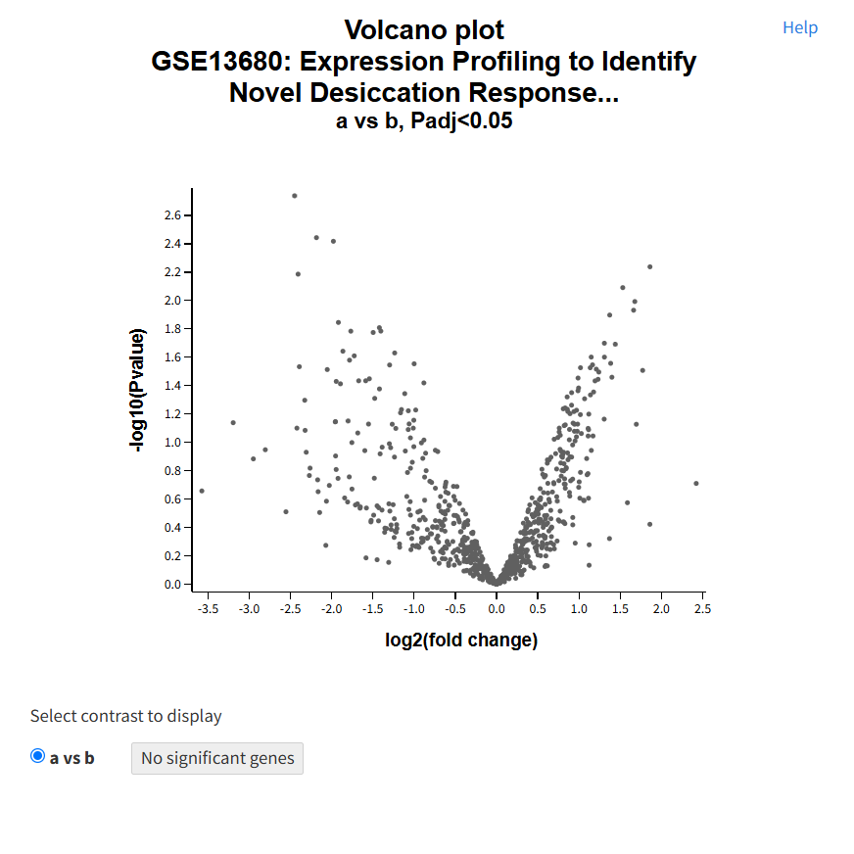

Volcano plot of *Tortula ruralis*

|  |
| --- |
|  |
|  | Slow-dried vs. hydrated gametophyte total RNA fraction |
|  | Rapid-dried Rehydrated vs. hydrated gametophyte total RNA fraction |